2017 Energy Smart Communities Initiative (ESCI) Best Practices Awards Program
Winners Announcement
This year, we are glad to have 197 cases from 21 APEC economies participated in the 2017 ESCI Best Practices Awards Program. The 25 finalists come from 11 economies were undergoing the stress and strain of tough semi-final competition to become the last 10 winners.
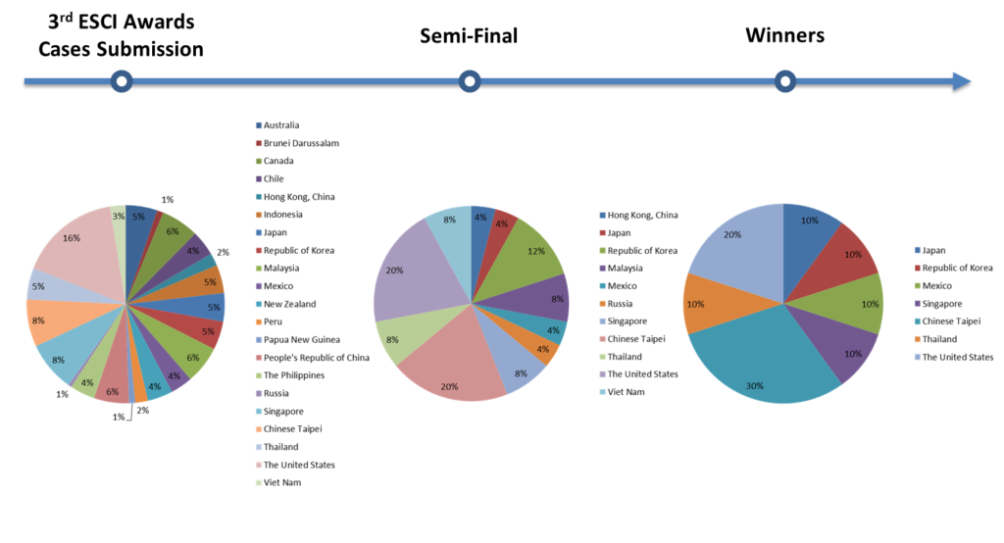
The below winning team should receive an invitation email from ESCI management team to attend the Awards Ceremony and Presentation (associated with the 53rd meeting of APEC Energy Working Group, EWG53) in Singapore. Please contact info@esci-ksp.org and d32375@tier.org.tw if you haven’t received it yet.

Pillar | Rank | Project Name | Economy
Smart Transport | Gold | Smart Park ICT Re-engineering Initiative  Case Sharing in Award Ceremony | Chinese Taipei
Smart Transport | Silver | California Electromobility Roadmaps | United States
Smart Buildings | Gold | Smart City Shioashiya “Solar-Shima”  Case Sharing in Award Ceremony | Japan
Smart Buildings | Silver | Energy Conservation Virtue at Huachiew Chalermprakiet University  Case Sharing in Award Ceremony | Thailand
Smart Grids | Gold | Entergy New Orleans “SmartView” AMI Pilot | United States
Smart Grids | Silver | Penghu Dongjiyu Microgrid Small Power Supply System  Case Sharing in Award Ceremony | Chinese Taipei
Smart Jobs and Consumers | Gold | BCA Back to School Programme:  Getting student alumni to be involved in greening of schools  Case Sharing in Award Ceremony | Singapore
Smart Jobs and Consumers | Silver | Applied Leadership Program for Renewable Energies and Energy Efficiency in Mexico  Case Sharing in Award Ceremony | Mexico
Low Carbon Model Towns | Gold | Solar Powered City – Tainan Reaches for the Sun​  Case Sharing in Award Ceremony | Chinese Taipei
Low Carbon Model Towns | Silver | Songdo, Korea | Korea

Qualifier Announcement
The qualifiers were informed by email, and if you haven’t received the notification, please do not hesitate to contact Janet Song (d32375@tier.org.tw) for further detail. The self-assessment statement is expected to be sent to info@esci-ksp.org and d32375@tier.org.tw by 03 Feb 2017.
The projects are ordered by Economy (A to Z).
Pillar | Project Name | Economy
Smart Transport | Smart Park ICT Re-engineering Initiative | Chinese Taipei
Smart Transport | Namyangju, Korea – Smart Transportation Network | Korea
Smart Transport | Avista Electric Vehicle Supply Equipment Pilot | United States
Smart Transport | California Electromobility Roadmaps | United States
Smart Transport | Ho Chi Minh City Green Transport Development | Vietnam
Smart Buildings | Smart City Shioashiya “Solar-Shima” | Japan
Smart Buildings | Building Sector Energy Efficiency Project | Malaysia
Smart Buildings | Low Energy Office (LEO) | Malaysia
Smart Buildings | Piloting a New Paradigm for Continuous Commissioning of Chiller Plant | Singapore
Smart Buildings | Energy Conservation Virtue at Huachiew Chalermprakiet University | Thailand
Smart Grids | Penghu Dongjiyu Microgrid Small Power Supply System | Chinese Taipei
Smart Grids | Smart Grid Station of Korea Electric Power Corporation | Korea
Smart Grids | PEA Smart Grid Project in Pattaya | Thailand
Smart Grids | Entergy New Orleans “SmartView” AMI Pilot | United States
Smart Grids | Ta’u Island Microgrid | United States
Smart Jobs and Consumers | Energy Education Treasure Chest | Chinese Taipei
Smart Jobs and Consumers | Guantian agriculture wastes reused and energy recycled training program  – Biochar of water caltrop shells | Chinese Taipei
Smart Jobs and Consumers | Applied Leadership Program for Renewable Energies and Energy Efficiency in Mexico | Mexico
Smart Jobs and Consumers | BCA Back to School Programme: Getting student alumni to be involved in greening of schools | Singapore
Smart Jobs and Consumers | Solar Training Network | United States
Low Carbon Model Towns | Guangzhou Knowledge City | China
Low Carbon Model Towns | Great Tainan – The Solar City | Chinese Taipei
Low Carbon Model Towns | Songdo, Korea | Korea
Low Carbon Model Towns | Skolkovo | Russia
Low Carbon Model Towns | Binh Duong New City | Vietnam

Eligibility
The Awards will be open to both the public and private sectors who have submitted cases on the ESCI-KSP website (http://esci-ksp.org/). Below are two kinds of cases that are eligible for the program:
- New cases (submitted after 31 July 2015) which are being proposed, current undertaken or accomplished.
- Previously-submitted cases (submitted before 31 July 2015) which are renewed with new scope of projects, progress, achievement, and etc. after 31 July 2015.
All the above cases must be submitted electronically via ESCI-KSP by 15 December 2016.

Criteria
The Awards will be made in four main pillars—Smart Transport, Smart Buildings, Smart Grids, Smart Jobs and Consumers, and one cross-cutting examples of Low Carbon Model Towns of ESCI. Judging will consider the cases’ articulation of and compatibility with its goals, its implementation and outcomes.
Time Table Information
12 MAY 2016 | Competition Announcement (on EWG51)
22 AUG 2016 | - Release Administrative Circular  - Call for nominations of Juries
31 OCT 2016 | Jury Committee Established
15 DEC 2016 | Cases Submission Deadline  No entries will be considered after 15 DEC 2016.
09 JAN 2017 | Qualifier Announcement  For each category, 5 cases will be selected by the Jury to proceed to the next phase.
03 FEB 2017 | Self-assessment Statement Submission  Cases making the finals will be required to submit self-assessment statements by 03 FEB 2017.
3 MAR 2017 | Winner Announcement  2 winners (Gold & Silver) will be chosen for each category
24 APR 2017 | Awards Ceremony and Presentation  (associated with 53rd meeting of APEC Energy Working Group, EWG53 in Singapore)

