Winner Announcement
Pillar | Rank | Project | Economy
Smart Transport | Gold | The Future is Electric – Queensland’s Electric Vehicle Strategy | Australia
Smart Transport | Silver | Autonomous Driving Taxi in Tokyo: World’s first service trial on public roads | Japan
Smart Buildings | Gold | Design and Construction Integration (EPC) Project of PNG and China Friendship School——Butuka Academy  Sharing in Award Ceremony | China
Smart Buildings | Silver | Building Energy Efficiency Program——Xintang Center  Sharing in Award Ceremony | China
Smart Grids | Gold | Aggregate Smart Public Housings to Develop the First Virtual Power Plant in Chinese Taipei  Sharing in Award Ceremony | Chinese Taipei
Smart Grids | Silver | Carnarvon Distributed Energy Resources (DER) trial  Sharing in Award Ceremony | Australia
Smart Grids | Silver | Smart Integrated Energy Microgrid in Customer Service Center of State Grid Corporation of China  Sharing in Award Ceremony | China
Smart Jobs and Consumers | Gold | Resource Smart Schools | Australia
Smart Jobs and Consumers | Silver | Energy Education Initiative | The United States
Low Carbon Model Towns | Gold | Vancouver, Canada | Canada
Low Carbon Model Towns | Silver | Hai Phong City  Sharing in Award Ceremony | Viet Nam
Qualifier Announcement
The qualifiers will be informed by email. If you haven’t received the notification, please do not hesitate to contact Janet Song (d32375@tier.org.tw) for further details. The self-assessment statement is expected to be sent to info@esci-ksp.org and d32375@tier.org.tw by 31 May 2019.
In accordance with APEC practices, the finalists are listed in alphabetical order as below.
Qualifier Announcement
Pillar | Project | Economy
Smart Transport | The Future is Electric – Queensland’s Electric Vehicle Strategy | Australia
Smart Transport | Transportation 2030: Green and Innovative Transportation | Canada
Smart Transport | Autonomous Driving Taxi in Tokyo: World’s first service trial on public roads | Japan
Smart Transport | Smart Transportation Innovation Program | The Republic of Korea & The United States
Smart Transport | Intelligent transport system and traffic management in Hong Kong | Hong Kong, China
Smart Buildings | Council House 2 | Australia
Smart Buildings | Building Energy Efficiency Program——Xintang Center | China
Smart Buildings | Design and Construction Integration (EPC) Project of PNG and China Friendship School——Butuka Academy | China
Smart Buildings | S.M.A.R.T I-C-C program | Hong Kong, China
Smart Buildings | System development and operation evaluation for low-carbon, smart green buildings | Chinese Taipei
Smart Grids | Carnarvon Distributed Energy Resources (DER) trial | Australia
Smart Grids | Smart Integrated Energy Microgrid in Customer Service Center of State Grid Corporation of China | China
Smart Grids | ‘’NO MORE BROWNOUTS!”-The Paluan Solar-Battery Microgrid | The Philippines
Smart Grids | Aggregate Smart Public Housings to Develop the First Virtual Power Plant in Chinese Taipei | Chinese Taipei
Smart Grids | JUMPSmartMaui | The United States
Smart Jobs and Consumers | Resource Smart Schools | Australia
Smart Jobs and Consumers | Energy Revealed Program | Canada
Smart Jobs and Consumers | Energy Technology and Environmental Education | Chinese Taipei
Smart Jobs and Consumers | Energy Education Initiative | The United States
Smart Jobs and Consumers | Virginia Energy Sense | The United States
Low Carbon Model Towns | Vancouver, Canada | Canada
Low Carbon Model Towns | Palembang City | Indonesia
Low Carbon Model Towns | Low Carbon Auckland | New Zealand
Low Carbon Model Towns | Lima-Callao, Peru | Peru
Low Carbon Model Towns | Hai Phong City | Viet Nam

TIME TABLE
The benchmarks and their respective closing dates are as follow:
06 NOV 2018 | Competition Announcement
31 MAR 2019 | Cases Submission Deadline
30 APR 2019 | Qualifier Announcement  For each category, 5 cases will be selected by the Jury to proceed to the next phase.
31 MAY 2019 | Self-assessment Statement Submission  Cases making the finals will be required to submit self-assessment statements by 31 MAY 2019.
05 JUL 2019 | Winner Announcement  2 winners will be chosen for each category
LATE 2019  (Date to be determined) | Award Ceremony  (associated with 58th meeting of APEC Energy Working Group in Chile)

CRITERIA
Judging will consider the cases’ articulation and compatibility with its goals, its implementation and outcomes. In the Qualifying Round, Jury will review cases with criteria marked in green. In Final Round, Jury will review cases with criteria marked in blue at great lenth and with 5-point system.
The criteria are: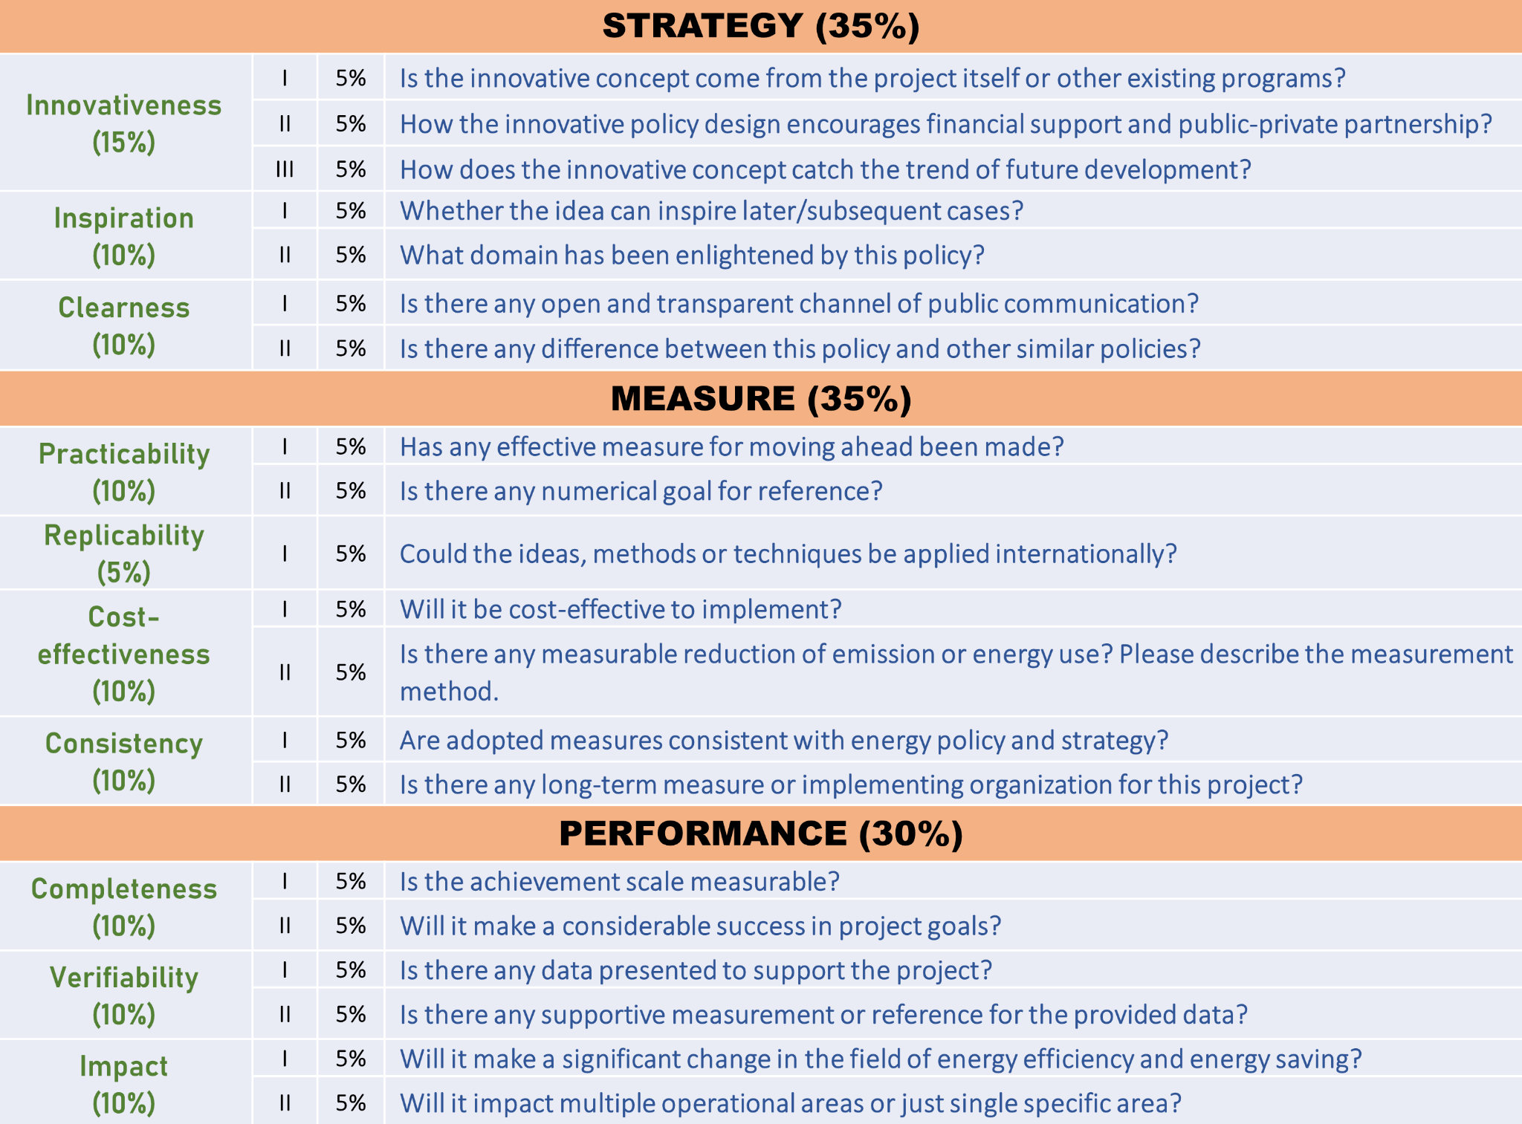
The 5-point system for the Final Round review is:
- ​Level 1: Not Mentioned –1 POINT
- ​Level 2: Mentioned but not Described –2 POINTS
- ​Level 3: Mentioned, described but not in detail –3 POINTS
- ​Level 4: Mentioned, and described in detail –4 POINTS
- ​Level 5: Mentioned, described in detail and provide examples –5 POINTS

