Low-Carbon Power Planning and Operation Decision-Making Platform:
Depicting the Transformation Path of Green Power System

Overview
With growing concern about climate change and carbon emission, low-carbon energy transformation has been an international consensus. The power system is a crucial sector for carbon emission reduction. How to depicting its transformation path is drawing growing attention both in China and abroad. APEC member countries have put forward their energy transformation goals. Such as, Australian government announced to achieve 80% of its electricity from renewable energy by 2035 and achieve near-zero carbon emissions by 2050. Japan proposed to increase the proportion of renewable energy and nuclear power to 36-38% and 20-22% of total electricity respectively by 2030 and achieve carbon neutrality by 2050. China will strive to achieve carbon peak by 2030 and carbon neutrality by 2060. To achieve the goal of low-carbon energy transformation, it is necessary to design the transformation path at both macro and micro levels. This includes the design of regional/provincial power transformation paths, as well as how to achieve the most economic and efficient green electricity consumption in low-carbon industrial parks. The core issue underlying these considerations is planning. The installed capacity of renewable energy in China has grew rapidly, surpassing 1 billion kW up to now. The surge of renewable energy and the tightening of carbon constraints have brought a series of challenges to power system planning and operation, especially how to model a secure, economic and low-carbon transformation scenario. For instance, there is a lack of accurate carbon emission monitoring methods. Additionally, the massive uncertainty scenarios of renewable energy are difficult to simulate, the coupling mechanisms of new technologies and elements with “electricity-heat-hydrogen-carbon” are unclear. What’s more, it is challenging to depict the operational status under high uncertainty, and the precision and efficiency of model solutions is also difficult to balance. To address the aforementioned challenges, State Grid Energy Research Institute has developed the Low-Carbon Power Planning and Operation Decision-Making Platform, which seamlessly integrates carbon emission monitoring, renewable energy uncertainty simulation, power system planning and operation simulation. The platform has been widely applied in the regional power system planning, urban carbon reduction strategy, building scheme of low carbon industrial park, and achieved good economic and social benefits.

Questions and Challenges
Under the pressure of climate change, promoting energy transformation to reduce carbon emissions has been an international consensus. There are two key issues to promoting the low-carbon transformation of the power system. Firstly, Tracking the distribution of carbon emissions in the power system is the foundation for emission reduction, as well as the prerequisite of power system carbon trading. However, scientific and accurate carbon emission tracing and tracking of power system faces significant challenges. Secondly, Increasing the proportion of renewable energy generation is the most important means for low-carbon transformation in the power system. The biggest challenge lies in how to address the uncertainty, safety, and economic challenges brought by high renewable penetration. Currently, the scale of renewable energy is rapidly growing worldwide, especially in China. China added 300 GW new installed capacity of wind and solar power in 2023, which is equivalent to the cumulative installed capacity of renewable energy in the United State. Until now, the capacity of renewable energy in China has exceeded 1000 GW, ranking first in the world. The output of renewable energy exhibit randomness and volatility, making it difficult to provide stable and reliable power supply like traditional generators such as coal-fired power. This may lead to imbalances in power supply and demand.
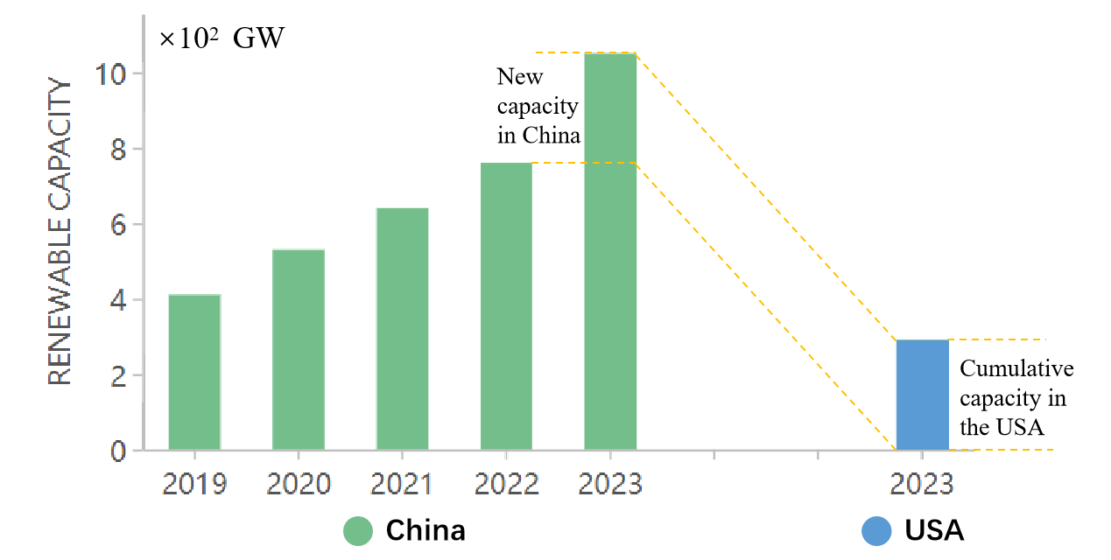
Figure 1 Renewable energy development in China and the United States
Generally speaking, the green transformation of power system must address the following questions:
- How to accurately monitor carbon emissions in power production, transmission, storage, and utilization?
- How to take into account the uncertainty of renewable energy in power system planning and operation?
- How to plan the power system with a high proportion of renewable energy considering carbon constraint, strong uncertainty, demand response and other new factors?
- How to comprehensively analyze the operating status of the power system and assess the economic feasibility of planning schemes?
To answer the above four questions effectively, a powerful power system planning and operation analysis software is needed. Currently, some mature power system planning software has been widely used internationally, such as ReEDS of National Renewable Energy Laboratory in the US and PLEXOS of Energy Exemplar in the AU. However, these models are not universally applicable to China, and are not good at considering carbon emissions and the uncertainty of renewable energy generation, making it difficult to analyze the adequacy of power system.
To develop a planning and operation decision platform suitable for Chinese power system, the following technical challenges:
- Unclear in coupling mechanism between power flow and carbon emission flow in power system, making it difficult to accurately identify the distribution of carbon emissions in power production, transmission, storage, and utilization.
- Lack of modeling methods for renewable energy uncertainty and assessing methods of renewable energy confidence capacity.
- Lack of planning methods suitable for different scenarios (such as the regional power system planning, urban carbon reduction strategy design and building scheme of low carbon industrial park) and insufficient consideration of carbon emissions, renewable energy uncertainty, and new technologies such as P2X, hydrogen energy, CCUS, and energy storage.
- Lack of model solving algorithm to solve the “curse of dimensionality” of refined operation simulation model, and it is difficult to balance the precision and efficiency of model solutions.
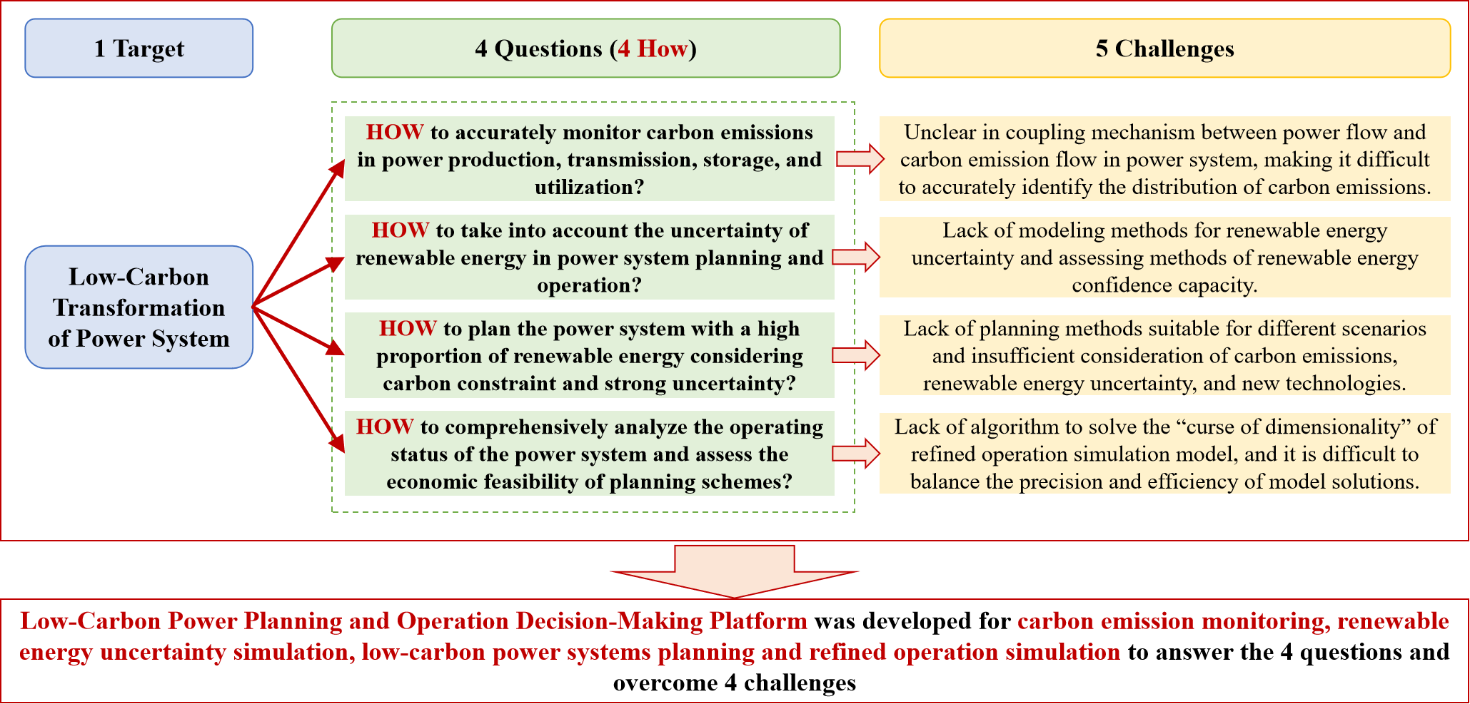
Figure 2 Challenges for low-carbon transformation of Chinese power system

Solution
In order to meet the above challenges, State Grid Energy Research Institute developed the Low-Carbon Power Planning and Operation Decision-Making Platform over a 8-year period, which integrates four functions: carbon emission monitoring, renewable energy uncertainty simulation, low-carbon power system planning, and refined operation simulation. The platform has been widely applied in planning the regional power system and designing urban carbon reduction strategy and building scheme of low carbon industrial park. Currently, it has been deployed in the State Grid Renewable energy Cloud Platform, Energy and Power Planning Laboratory of the State Grid Corporation of China (SGCC), as well as the low-carbon industrial park in several provinces.
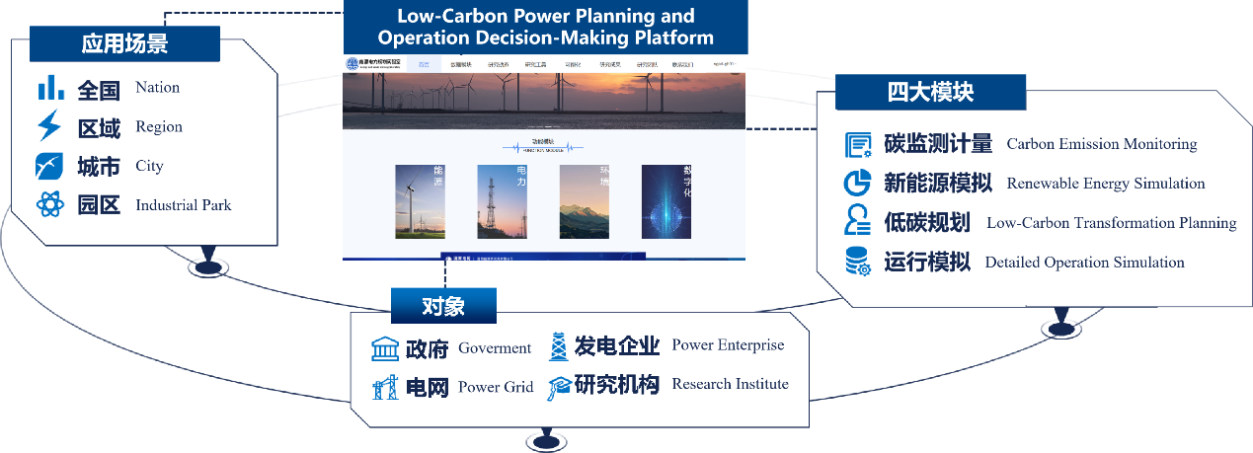
Figure 3 Low-Carbon Power Planning and Operation Decision-Making Platform
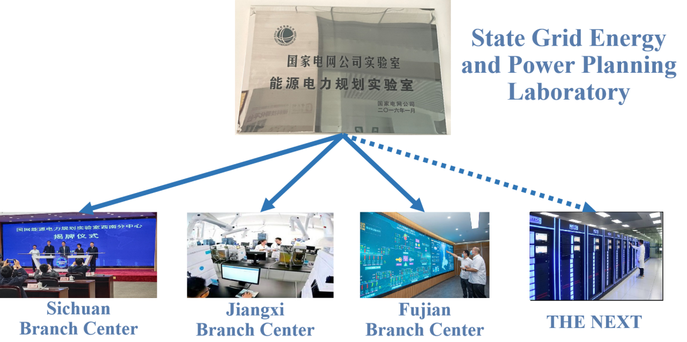
Figure 4 Energy and Power Planning Laboratory of the SGCC
The platform is composed of four submodules, these submodules can operate independently to realize the above four functions. Alternatively, through the flexible combination and interactive operation of different submodules, higher and richer functions can be achieved, such as low-carbon strategic planning and policy simulation.
The platform framework is shown in Figure 5.
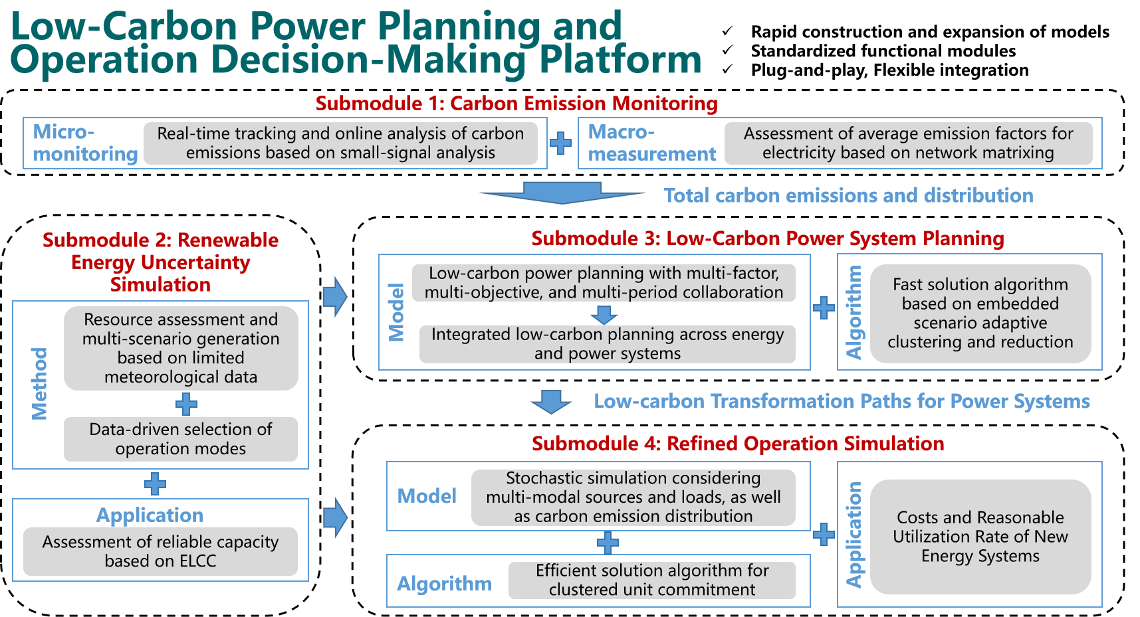
Figure 5 Framework of low-carbon power planning and operation decision-making platform
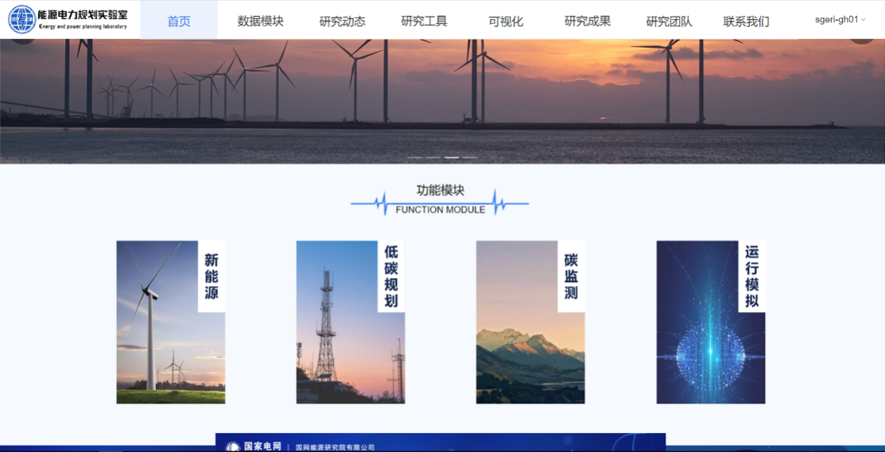
Figure 6 Home page of low-carbon power planning and operation decision-making platform
- Submodule 1: Carbon Emission Monitoring
Target: Tracking and monitoring carbon emissions of power generation, transmission, storage, and demand-side
Background:
Better understanding of carbon emission distribution among different aspects of power systems is the foundation for carbon emission reduction. Currently, carbon emission monitoring mainly focusses on the power generation side, lacking tracking and monitoring technologies for carbon emissions throughout the entire process of power generation, transmission, storage, and demand-side. To address these issues, the module of carbon emission monitoring was developed.
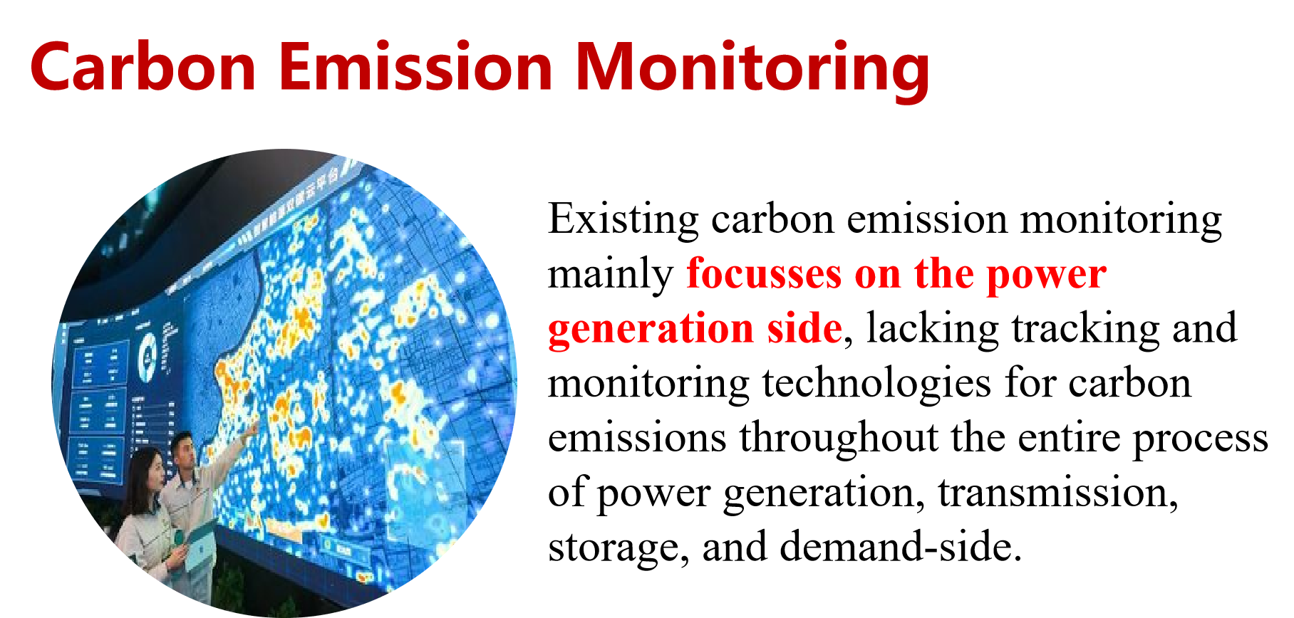
Figure 7 Challenges of Carbon Emission Monitoring
Function:
- Analysis of power system carbon emissions distribution on “node-level” precision. Submodule 1 establishes a high-precision mapping relationship between power flow and carbon emission flow though virtual network carbon emission transfer distribution model, which could reveal the spatial and temporal distribution of carbon emissions at node-level in power system, including generators, transformer substations, buses, loads, and energy storage nodes.
Technological Breakthrough：
Submodule 1 constructs a virtual network carbon emission transfer distribution model based on the coupling relationship between power flow and carbon emission flow. This model enables the real-time tracking of carbon emission of power system and precisely monitoring carbon emission flow distribution of each nodes in power system.
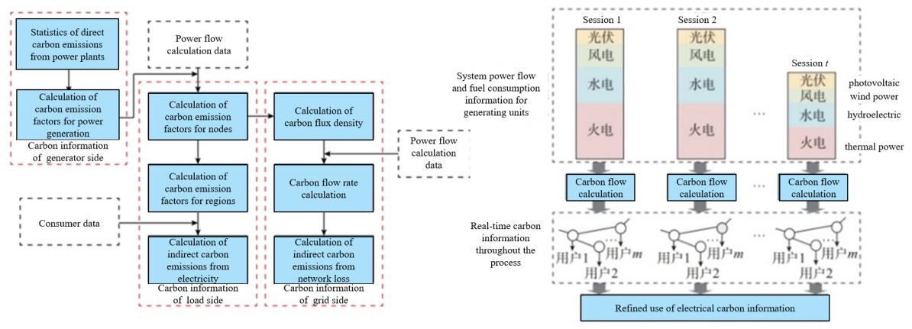
Figure 8 Technology for mapping and calculating carbon emissions from all aspects of the power system
Submodule Application:
- Submodule 1 was embedded in a carbon asset aggregation and management system and applied in urban carbon emission monitoring in Nanchang, Jiangxi province.
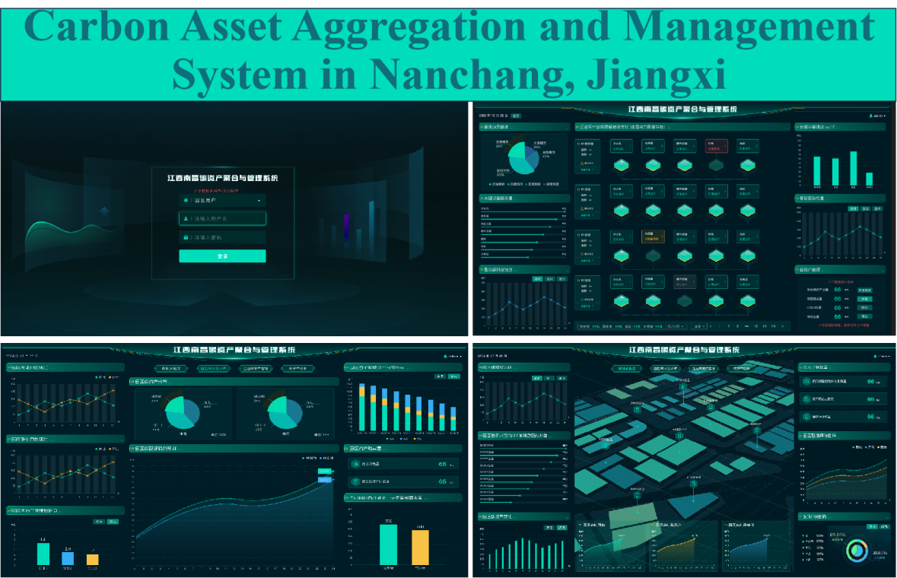
Figure 9 Carbon asset aggregation and management system
- The building scheme of Zero-Carbon Campus at Jiangxi Vocational and Technical College of Electricity was given by Submodule 1.
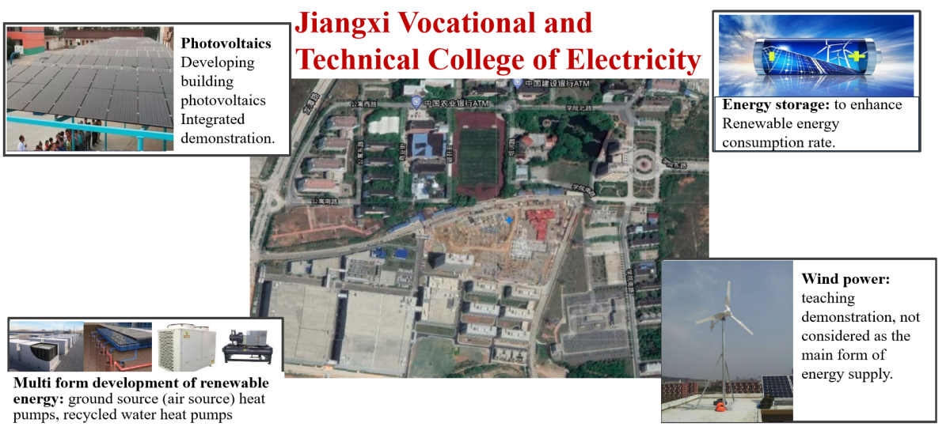
Figure 10 Zero-Carbon Campus at Jiangxi Vocational and Technical College of Electricity
- The carbon emission trend of China’s power system from 2020 – 2060 was analyzed by Submodule 1, and the relevant content was published as a part of the monograph “Analysis of Paths and Major Issues for Achieving Carbon Peaking and Carbon Neutrality in China's Energy and Power Industry”.
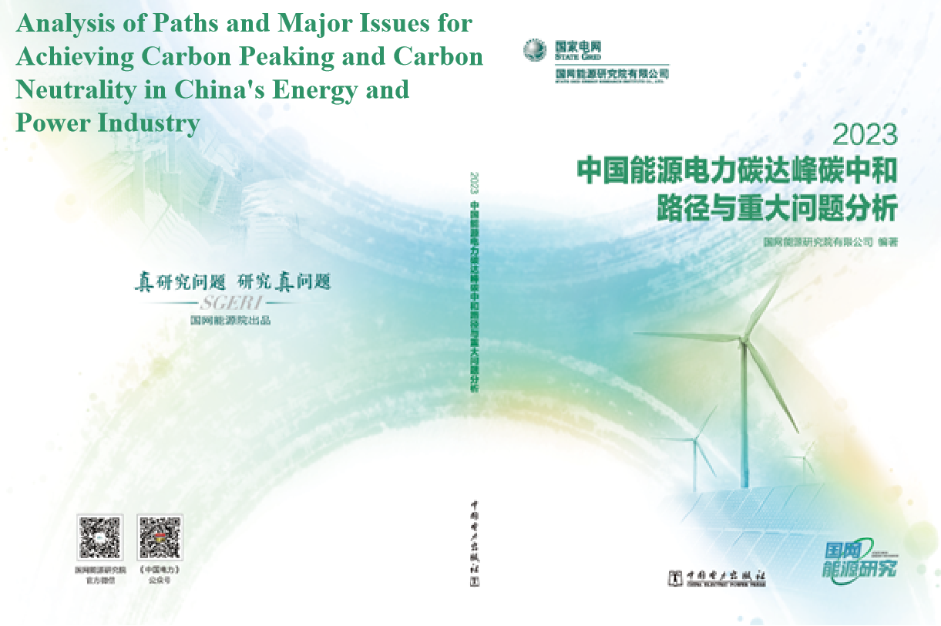
Figure 11 The monograph “Analysis of Paths and Major Issues for Achieving Carbon Peaking and Carbon Neutrality in China's Energy and Power Industry”
- Submodule 2: Renewable Energy Uncertainty Simulation
Target: Modeling of renewable energy uncertainty and assessing of renewable energy confidence capacity
Background:
Due to the probability distribution of wind and solar energy, massive scenarios should be generated to simulate the uncertainty of renewable energy output. However, massive scenarios make the planning and operation model too complex to solve. And it is difficult to cluster and screen the massive scenarios that simultaneously consider both the typicality and specificity of renewable energy output. In addition, traditional capacity evaluation methods generally assume that the confidence capacity of renewable energy is zero or a fixed value based on expert experience, which can lead to either conservative or aggressive planning schemes.
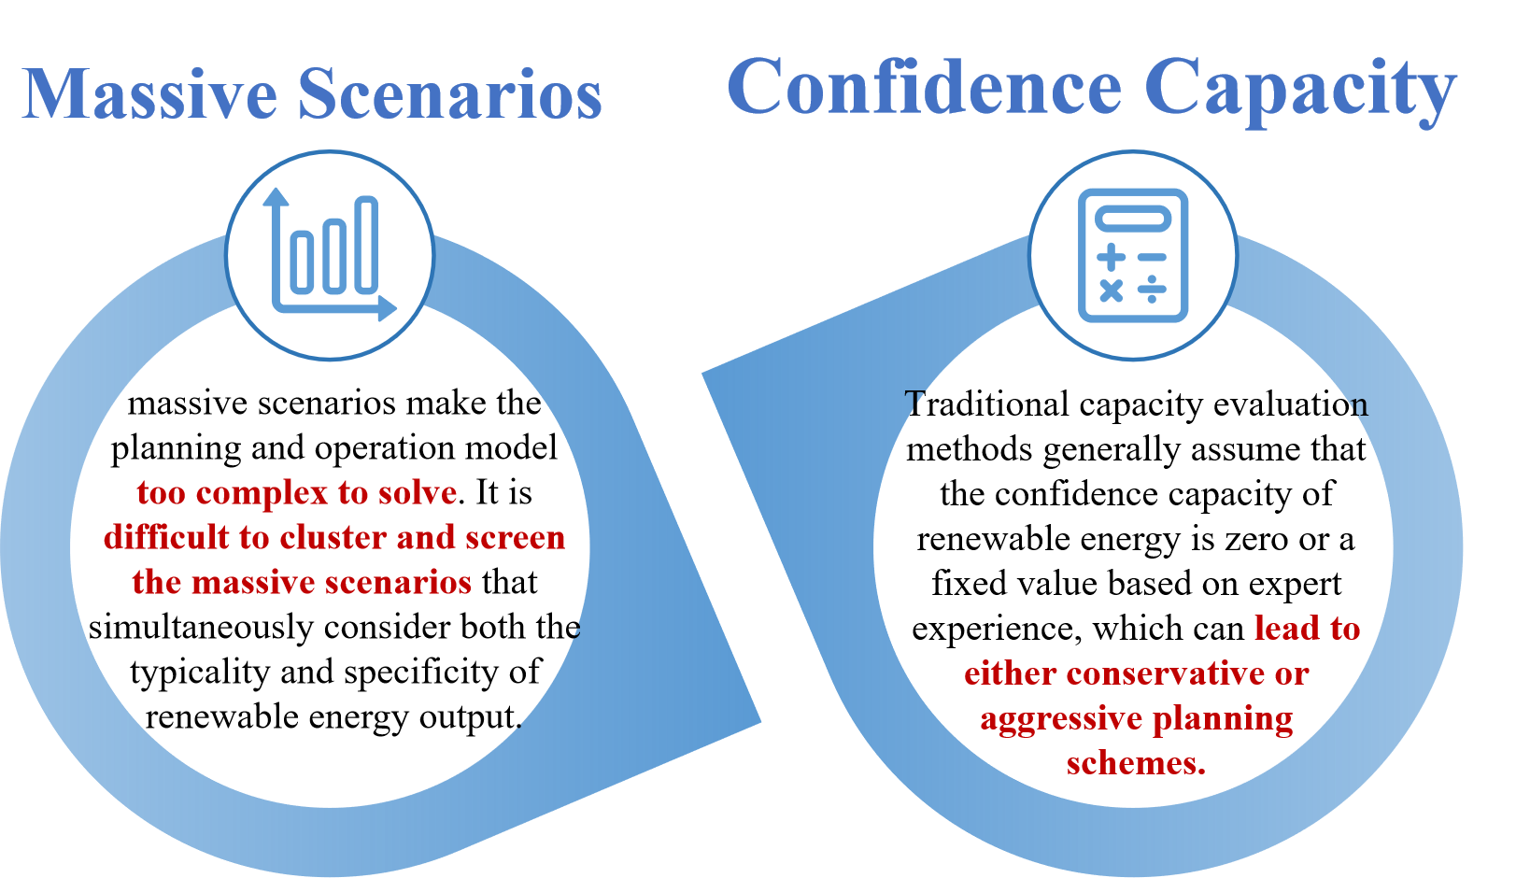
Figure 12 The challenges of renewable energy uncertainty simulation
Function:
- Massive scenarios generation of renewable energy generation output. Based on the statistical characteristics of renewable energy output, Monte Carlo Markov Chain (MCMC) simulation is utilized to generate time series of renewable energy output with identical statistical parameters, ensuring both the statistical properties and randomness of the renewable energy output series.
- Clustering and screening of massive scenarios. Typical scenarios with the highest probability are selected by K-means method, and the extreme scenarios should also be retained considering the randomness and volatility of renewable energy. Then, typical scenarios are used to accurately estimate power system operating costs in production simulation, and extreme scenarios are used to ensure safe and stable operation of power system.
- Confidence capacity evaluation of renewable energy generation. Confidence capacity refers to the contribution of a power plant to reliably meet peak power demand. This implies that if a 100 MW solar plant has a confidence capacity of 50%, it can contribute 50 MW of power to reliably meet demand, and thus reduce the strain on conventional power generation plants. Submodule 2 evaluate the confidence capacity of renewable energy based on effective load carrying capability during peak-load-period.
Technological Breakthrough：
Submodule 2 proposes an evaluation method of renewable energy based on limited meteorological data, massive operating mode simulation, and clustering techniques. This approach overcomes challenges such as limited data volume, insufficient recording duration, and difficulty in selecting the number of states for simulating the randomness of renewable energy sources. Additionally, by improving the ELCC algorithm to calculate the equivalent load capacity of renewable energy sources at a certain confidence level, the submodule can reasonably assess the ability of renewable energy sources to participate in power system balancing, thereby reducing the risk of power supply insufficiency.
Firstly, the MCMC based massive scenarios generation technology was proposed. Addressing the challenge of selecting the appropriate number of states in existing Markov process-based simulation methods, an optimized state number selection approach for Markov Chain Monte Carlo (MCMC) was proposed based on the cumulative distribution function random power generation method. This approach can simulate massive scenarios while preserving key statistical characteristics. Secondly, a big data analysis framework and algorithm for massive renewable energy scenarios and power system operation modes have been proposed, addressing the challenges of selecting typical and extreme scenarios in power planning and operation analysis. This framework introduces preprocessing, dimension reduction, and screening techniques for massive renewable energy scenarios based on aggregated Euclidean distance. It can provide a set of typical and extreme state scenarios for power system planning and operation. Finally, the evaluation model for the confidence capacity of renewable energy based on the improved Equivalent Load Carrying Capacity (ELCC) was established. This model can effectively evaluate the confidence capacity of renewable energy while avoiding the risk of power insufficiency.
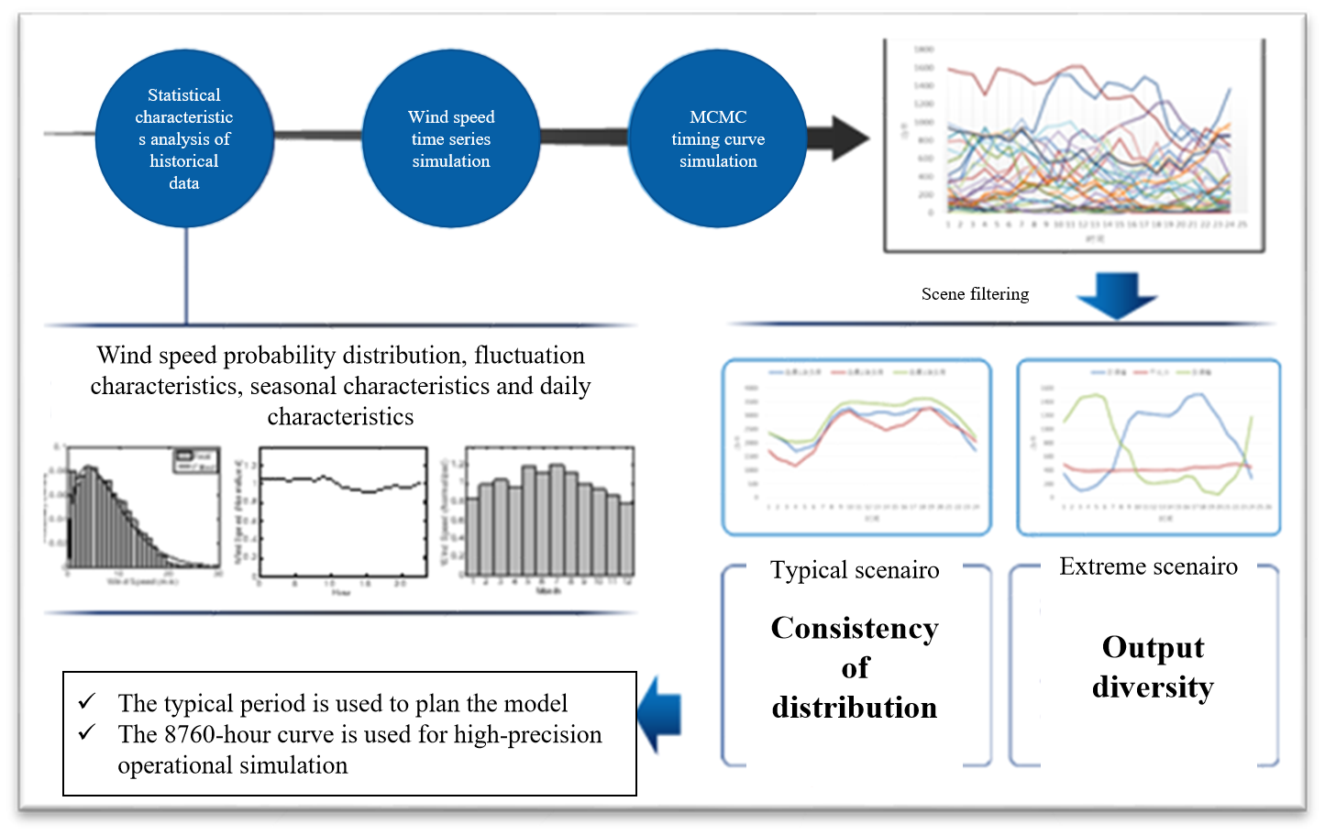
Figure 13 Assessment of renewable energy resource characteristics and massive scenario simulation
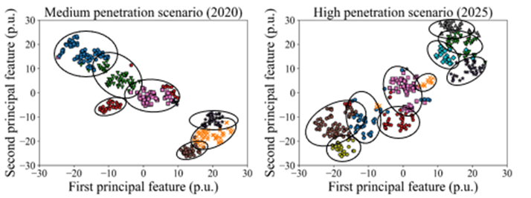
Figure 14 Typical/extreme scenario sets adapted for planning and operation analysis
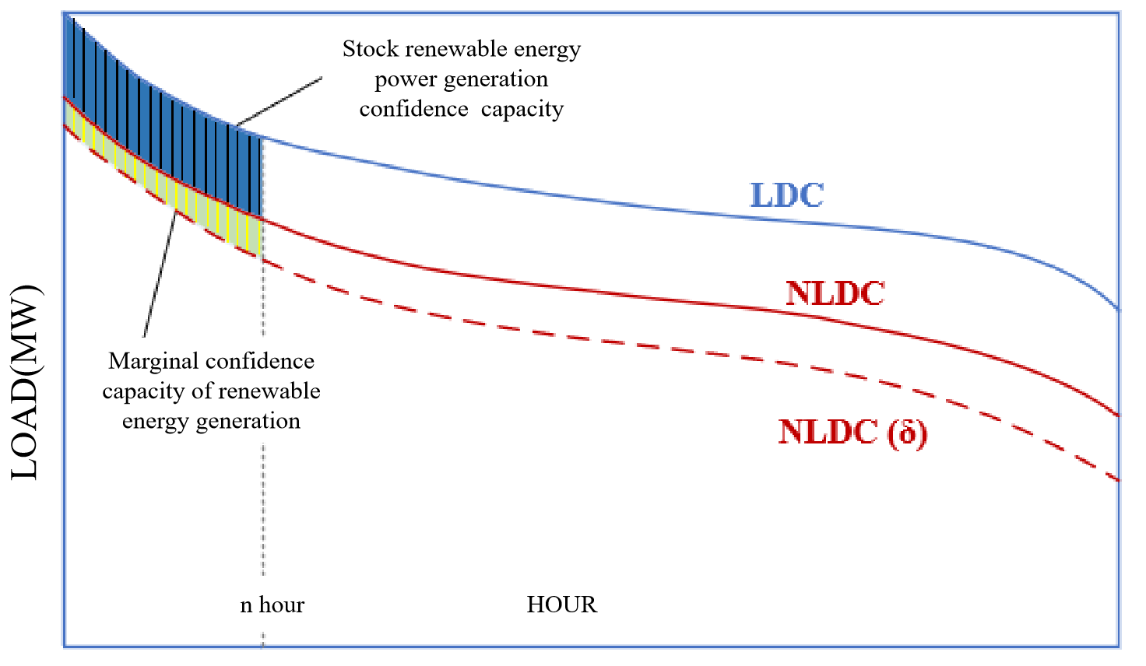
Figure 15 Assessment of credible capacity of renewable energy based on equivalent load capability
Submodule Application:
- Submodule 2 is applied by State Grid to determine the renewable energy dispatch and operation modes in the Beijing-Tianjin-Tangshan region every year since 2020.
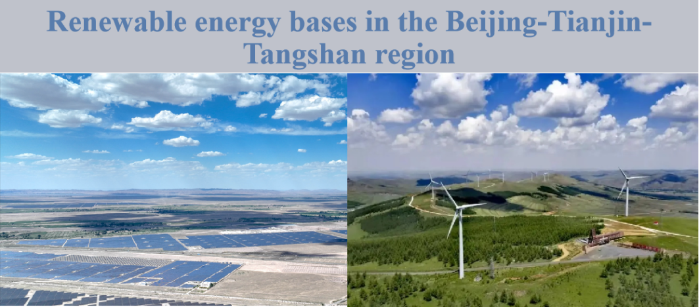
Figure 16 Renewable energy base in the Beijing-Tianjin-Tangshan region
- Submodule 3: Low-Carbon Power System Planning
Target:Mid-Term and Long-Term Planning for Low-Carbon Power Systems
Background:
With the increasing of renewable energy and tightening of carbon constraints, the new factors such as carbon emissions, renewable energy uncertainty, and new technologies of P2X, hydrogen energy, CCUS, and energy storage should be considered in the mid-term and long-term planning for low-carbon power systems. Additionally, the planning model of power system under the strong uncertainty has the characteristics of multi-stage, multi-scenario, and multi-variable, resulting in low efficiency of model solution.
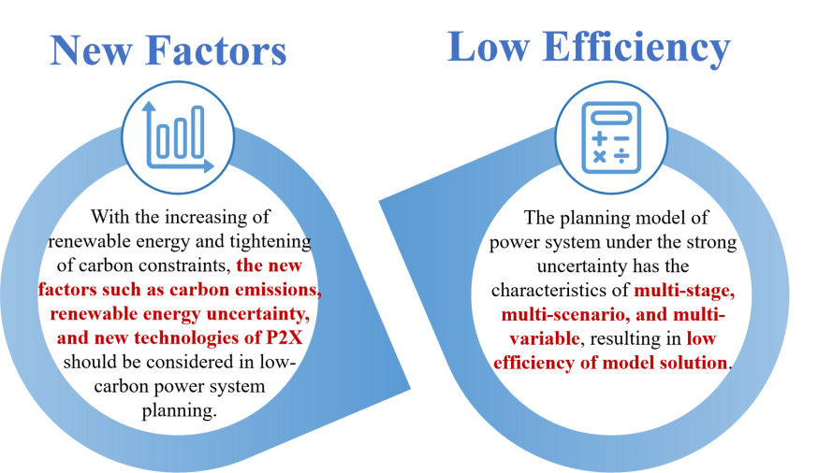
Figure 17 The challenges of low-carbon power system planning
Function:
- Capacity Expansion. Based on boundary conditions such as power demand forecasting and predictions of the economic trends of power generation technologies, the power capacity expansion plan with the lowest power supply cost is proposed, including the size, location and time of put into production for different types of power plants.
- Transmission Expansion. Submodule 3 can optimize the optimal scale of inter-regional power exchange, propose transmission capacity expansion plans and operation modes, joint optimize the generation portfolio and transmission capacity for renewable energy bases on the sending-end, and investigate the impact of different transmission technologies, voltage levels and operation modes.
- Analysis of rational ratio of wind and solar power curtailment. Submodule 3 can calculate the maximum install capacity of renewable energy under the constraint of a certain ratio of wind and solar power curtailment. It can also analyze the rational ratio of wind and solar power curtailment, and the optimal combination of measures to reduce wind and solar power curtailment from the perspective of lowest power supply cost.
Technological Breakthrough：
Firstly, a power system planning model considering carbon emissions and renewable energy uncertainty is established. The massive renewable energy scenarios are embedded into the power planning model, and the new factors such as carbon emissions, renewable energy uncertainty, and new technologies are introduced. Submodule 3 addresses the technical challenges of probabilistic power and energy balance and optimal planning of power system with a high proportion of renewable energy. What’s more, it enables synchronized optimization of low-carbon transformation paths for primary energy and power. Secondly, a rapid solution algorithm based on multi-parameter linear programming theory is proposed. The core of this approach is the use of Benders decomposition method to solve operational subproblems by introducing Monte Carlo random sampling. The multiplier averages of typical scenarios are used to approximate the averages of the original multiple scenarios, making inferences about the whole based on local characteristics. It can significantly improve the efficiency of model solving.
Figure 18 Low-carbon transformation planning model considering multi-objective, multi-period, and multi-factor collaboration
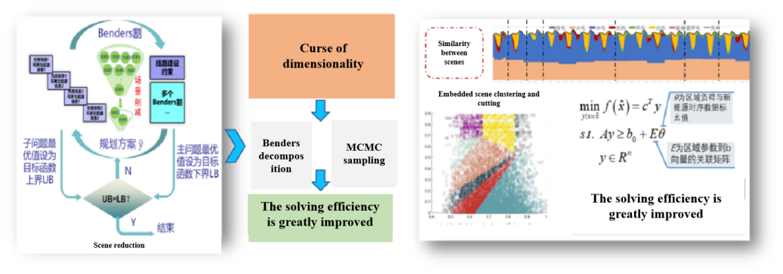
Figure 19 Efficient solution algorithm for low-carbon transformation planning model in energy and power industry
Submodule Application:
- The research on the implementation path for achieving carbon peak and neutrality in the power industry of the Chinese Academy of Engineering was completed relying on Submodule 3, and the relevant policy recommendations were proposed and adopted by the State Council of the PRC;
- The power system transformation path in the “Carbon Peak and Neutrality Action Plan” and the “New Power System Action Plan of the SGCC” were calculated by Submodule3 from 2020 to 2024;
- The carbon peak and neutrality path of Chinese power system was analyzed by Submodule 3, and the relevant content was published as a part of the monograph “Carbon Peak and Neutrality Path in Energy and Power Industry”, which is released publicly through Xinhua Finance with exceeded 360,000 audiences.
- Submodule 4: Refined Operation Simulation
Target: 8760-hour refined operation simulation of low-carbon power system
Background:
The main purpose is to carry out 8760-hour hour-by-hour production simulations of the power system by constructing a multi-area equivalent model of the power system, in order to analyze the operation status of the power system at each time section within any time period. Traditional power system operation simulations have difficulties considering the uncertainty of renewable energy and the spatial and temporal distribution of carbon emissions. Besides, it is difficult to balance the precision and efficiency of algorithm to solve the refined operation simulation model.
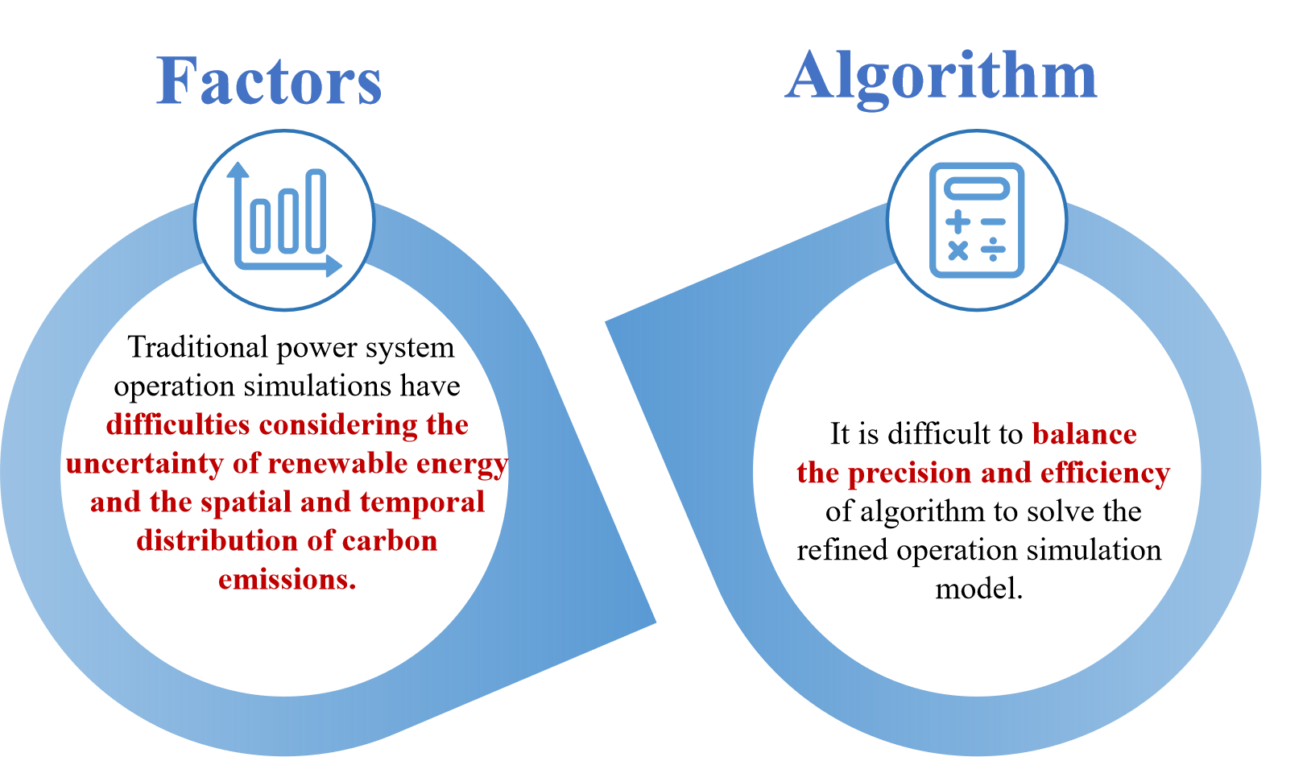
Figure 20 The challenges of refined operation simulation
Function:
- Analysis the operating status of power system. The operation status of power system at each hour can be obtained by 8760-hour refined operation simulation using Submodule 4. It includes the output of various generators, the power flow distribution of various transmission lines, carbon emissions of each nodes, and the adequacy and flexibility level of power system.
- Analysis of wind and solar power curtailment. Submodule 4 can analyze ratio of wind and solar power curtailment under a determined planning boundary. It can further evaluate the effectiveness of flexibility sources in reducing wind and solar power curtailment, such as flexibility retrofits for thermal power plants, gas-fired power plants, energy storage, and demand response.
- Economic analysis of power system operation. Submodule 4 can provide detailed operational costs for different scenarios. Such as the optimal system cost for the whole society in regional power system planning, the investment cost of urban power development or carbon reduction, and the operation cost of low carbon industrial park.
Technological Breakthrough：
Firstly, Submodule 4 embeds massive operation scenarios of renewable energy into the operation simulation model and proposes a transfer distribution factor algorithm to achieve adaptive clustering of embedded massive scenarios. Additionally, Submodule 4 proposes a rapid operation simulation algorithm for power systems based on a clustered unit commitment model.
The similar-performing generators are clustered, and only the unit commitment constraints of the clustered groups are considered. Thus, the number of 0-1 variables for unit start-stop decisions is significantly reduced, and the efficiency of operation simulation has increased by more than 100 times.
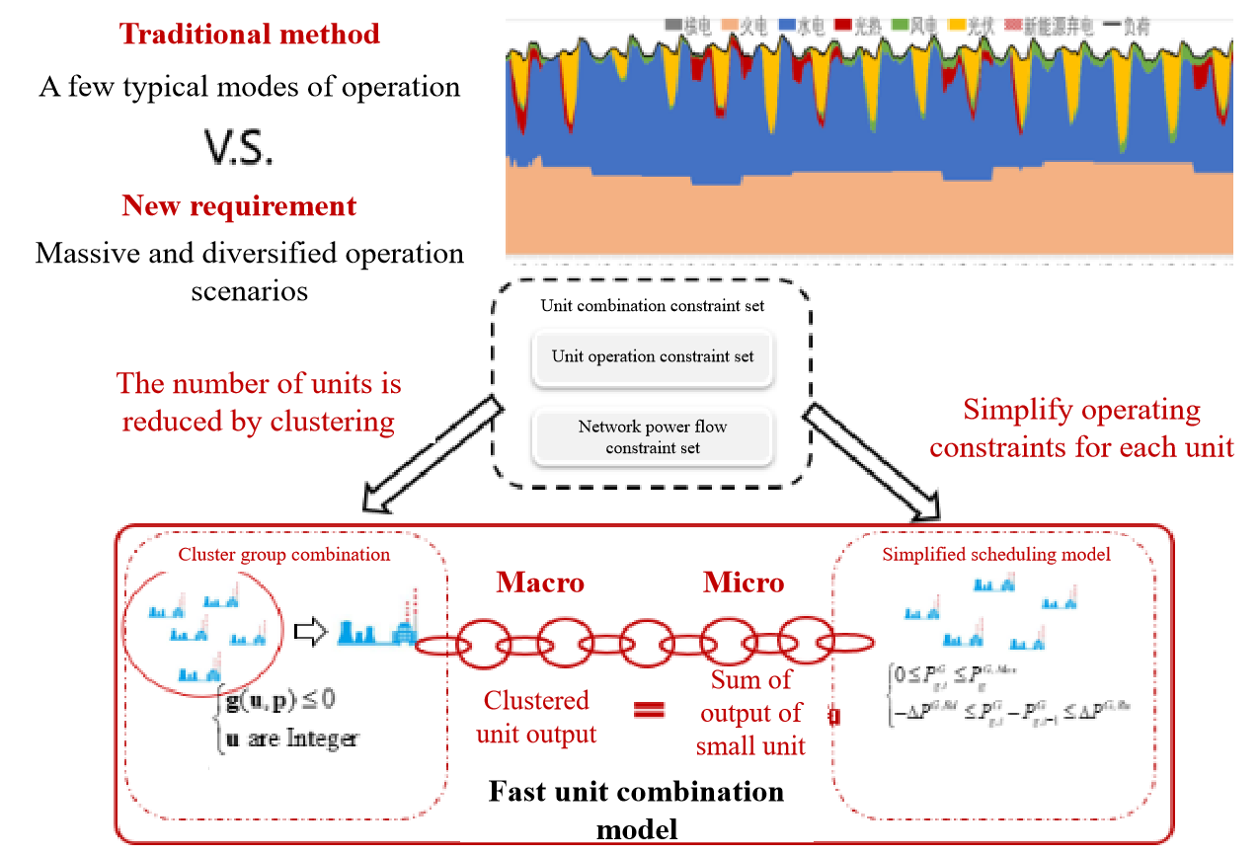
Figure 21 Efficient solution algorithm for power system optimized operation models
Submodule Application:
- Submodule 4 has been applied to calculate the ratio of wind and solar power curtailment in 26 provinces within the operational area of the SGCC for five consecutive years and puts forward effective suggestions reducing the ratio by more than 2%;
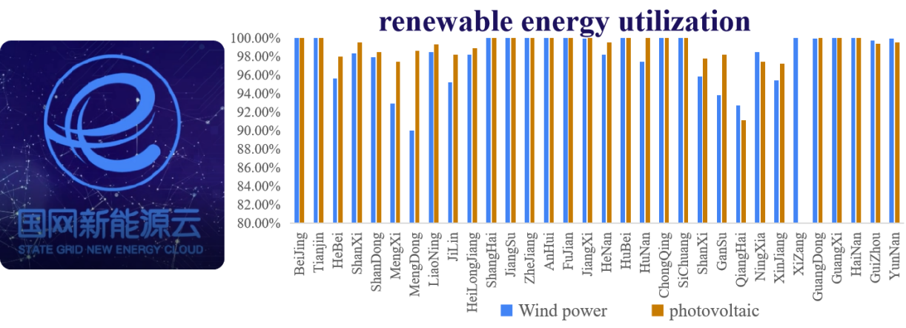
Figure 22 The the ratio of wind and solar power curtailment
- The collaborative operation simulation of both the sending and receiving ends of the YaZhong UHVDC Transmission Project was completed by Submodule 4.
The four submodules can operate independently to address different issues, or they can be combined to achieve integrated analysis and application for low-carbon power planning, based on functional modularization and interface standardization techniques. It addresses the challenges of coordination and mutual feedback among different modules of carbon emission monitoring, renewable energy uncertainty simulation, low-carbon power system planning, and refined operation simulation. Through large-scale application and iterative upgrades, the cutting-edge theoretical models have been honed into a highly practical and versatile analysis platform, providing practical and systematic analysis tools for power system planning.

Application and Potential Impacts
The platform has been widely used by various entities, such as national ministries and commissions, local governments, the World Bank, grid companies, and power generation groups. It has provided important decision-making tools and reference solutions in supporting the formulation of the national carbon reduction strategic plan, serving the low-carbon transformation of the energy and power industry, and assisting the SGCC and its subordinate grids in planning and building the power system with high renewable generation penetration.
- Economic benefit
- Cumulative investment 13 million CNY and direct economic benefit 137 million CNY. Relying on various scientific and technological projects, the cumulative investment in platform research and development is about 13 million CNY. In the past five years, relying on the key technical achievements and the platform, 88 technical consulting, service and transfer projects have been completed, and direct economic benefit have been achieved of 137 million CNY.
- Social benefit
- Renewable Energy Development
- Reducing wind and solar power curtailment. The platform has been applied by SGCC and its provincial subsidiaries to calculate the ratio of wind and solar power curtailment in 26 provinces and give effective suggestions to optimal renewable energy dispatch and operation modes and reduce wind and solar power curtailment.
(2) Low-Carbon Economy Development
- Promoting interconnectivity among market entities. Submodules has been integrated and applied on multiple industry-level platforms such as the State Grid’s Renewable energy Cloud. The platform connects the entire industry chain of low-carbon technology planning, design, and operation, facilitating interconnectivity among renewable energy companies, equipment manufacturers, operation and maintenance enterprises.
- Fostering carbon reduction industries. The carbon emission monitoring submodule provides data services and technical support for fostering carbon reduction industries.
- Building Low Carbon Community. Relying on the platform, State Grid Energy Research Institute established carbon asset aggregation and management system and applied in Zero-Carbon Campus at Jiangxi Vocational and Technical College of Electricity.
- Policy-Making
- Servicing government departments. The platform has demonstrated significant effectiveness in supporting the energy and power transformation, renewable energy development, and carbon monitoring of national ministries and commissions as well as local governments.
- Supporting policy formulation. The platform has also supported the issuance of multiple policies in the fields of energy storage and renewable energy development.
(4) Industry-university-research collaboration
- Sharing technological resources. Relying on project cooperation, the scientific and technological resources are shared with universities, industry associations, and key enterprises. The paid access to the platform is opened for partners and free educational software is provided to universities.
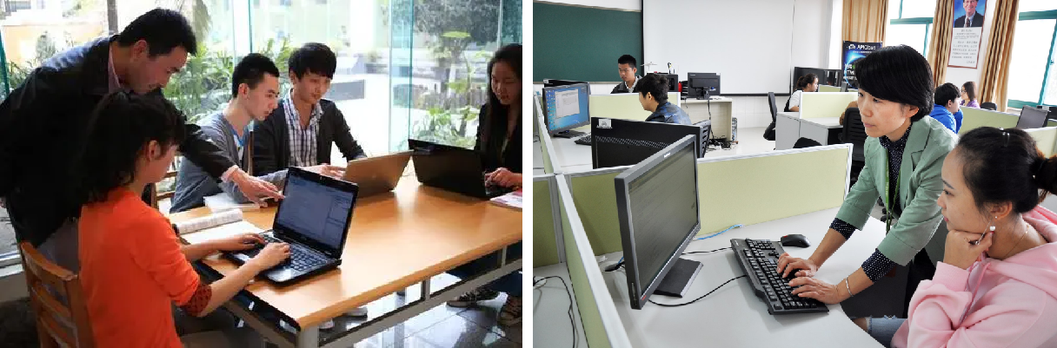
Figure 23 Free educational software provided to universities
- Establishing joint research institutions. State Grid Energy Research Institute has established several scientific institutions with partners by the application of the platform, including the Jiangxi (Nanchang) Carbon Neutrality Development Institute and the Shandong Dongying Smart Energy and Zero-Carbon Industry Development Institute.
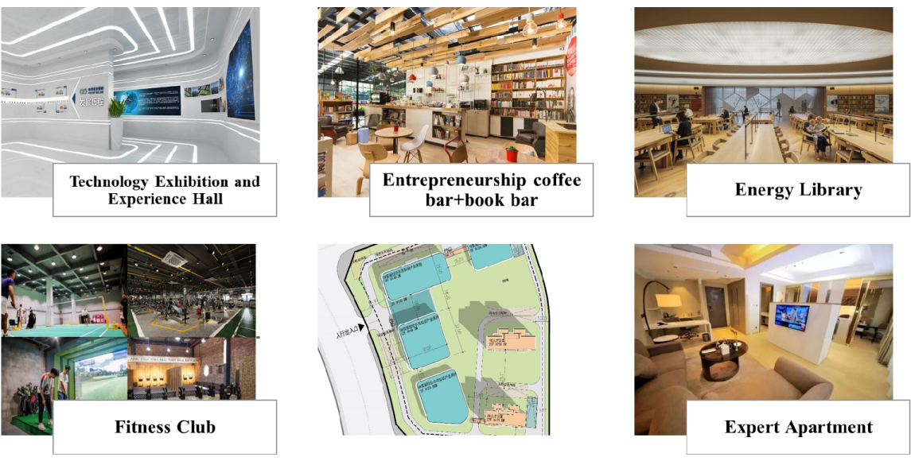
Figure 24 Jiangxi (Nanchang) Carbon Neutrality Development Institute
(5) Talent Training
In recent years, relying on the platform construction, a number of talents have been trained.
- Four researchers were awarded the title of professor-level senior engineers, including one female.
- Three researchers have been awarded the title of SGCC young talents.
- Two researchers have been awarded the title of Outstanding Young Scientific and Technological Workers by the China Energy Research Society.
- Five researchers have served as expert committee members in academic organizations such as the IEEE PES Energy Technology and Economics Committee.
The platform is continuously being developed and upgraded, aiming to contribute Chinese wisdom and inject green momentum into the global energy transformation.

